**Project Based Learning Report**

on

**Color Detection with OpenCV**

Submitted in the partial fulfillment of the requirements

For the Project based learning in **Essentials of Data Science**

in

Electronics & Communication Engineering

By

**2014111105 Anshika Sharma**

**2014111139 Kirti Kiran**

**2014111116 Swatantra Raj Kumar Singh**

Under the guidance of Course In-charge

Prof. Dnyandeo Lavhkare

Department of Electronics & Communication Engineering

Bharati Vidyapeeth

(Deemed to be University)

College of Engineering,

Pune – 4110043

**Academic Year: 2021-22**

**Bharati Vidyapeeth**

**(Deemed to be University)**

**College of Engineering,**

**Pune – 411043**

**DEPARTMENT OF ELECTRONICS & COMMUNICATION ENGINEERING**

**CERTIFICATE**

Certified that the Project Based Learning report entitled, **“Color Detection with OpenCV”** is work done by

**2014111105 Anshika Sharma**

**2014111139 Kirti Kiran**

**2014111116 Swatantra Raj Kumar Singh**

in partial fulfillment of the requirements for the award of credits for Project Based Learning (PBL) in **Essentials of Data Science** of Bachelor of Technology Semester IV, in Electronics and Communication Engineering.

**Date: 23rd May 2022**

**Prof. Dnyandeo Lavhkare Dr. Tanuja S. Dhope**

**Course In-charge PBL Co-Ordinator**

**Dr. Arundhati A. Shinde**

**Professor & Head**

**ELECTRONICS & COMMUNICATION ENGINEERING**

**INDEX**

|  |
| --- |
| **Serial No. Title Page No.** |

|  |  |  |
| --- | --- | --- |
| **1** | Problem Statement and it’s solution | 1 |
| **2** | Project Description | 2-3 |
| **3** | Results and Analysis | 4-6 |
| **4** | Program Code | 7-8 |
| **5** | Conclusion | 9 |

**Problem Statement**

The process of detecting the name of any color in an image is known as color detection. This is an exceedingly simple task for humans, but it is not that simple for computers. The eyes and brains of humans work together to convert light into color, unlike computers.

**Solution of Problem Statement**

To solve this problem, we Build an application to detect colors with Beginner Data Science Project, i.e., Color Detection with OpenCV.

**1**

**Project Description**

Dataset Used for Color Detection

Red, green, and blue are the three primary colors that make up any color available. Each color value in a computer is defined as a number between 0 and 255. A color can be represented in around 16.5 million different ways. We need to translate the values of each color to their names using our dataset. We’ll be working with a dataset that contains RGB values along with their names.

Importing OpenCV

The first step is to import all the required modules along with OpenCV, and then load the image but make sure the image is inside the same folder as the code file.

**import** cv2

**import** pandas as pd

img **=** cv2.imread("colorpic.jpg")

Load the “colors.csv” file

We make use of the pandas library to do operations on data files like CSV. And pd.read_csv() function is used to load and read the CSV file. We also assign each column with a name in the index list for making access easier.

index **=** ["color", "color_name", "hex", "R", "G", "B"]

data **=** pd.read_csv("colors.csv", names**=**index, header**=**None)

Creating a window and a callback function

First, we must create a fresh window in which the input image will display. Then, we provide a callback function that will be activated only when a mouse event happens across the image.

cv2.namedWindow("Color Detection Window")

cv2.setMouseCallback("Color Detection Window",call_back_function)

But now we have to create a callback function mentioned by the name of call_back_function.

Creating the Callback Function

Let’s understand what this callback function will do: It will calculate the rgb values of the pixel which we double click and the (x,y) coordinates of the mouse position are saved.

**2**

**def** call_back_function (event, x,y,flags,params):

**if** event **==** cv2.EVENT_LBUTTONDBLCLK:

**global** b,g,r,xpos,ypos, clicked

        clicked **=** True

        xpos **=** x

        ypos **=** y

        b,g,r **=** img[y,x]

        b **=** int(b)

        g **=** int(g)

        r **=** int(r)

Extracting color name from rgb values

Now that we have extracted the rgb values from the image, now we need to change the rgb values to the color name. The same is done in the function below.

**def** get_Color_Name(R,G,B):

    minimum **=** 10000

**for** i **in** range(len(csv)):

        d **=** abs(R**-** int(csv.loc[i,"R"])) **+** abs(G**-**int(csv.loc[i,"G"]))**+** abs(B**-**int(csv.loc[i,"B"]))

**if**(d<**=**minimum):

            minimum **=** d

            cname **=** csv.loc[i,"color_name"]

**return** cname

To get the color name, we calculate a distance(d) which tells us how close we are to a specific color and choose the one which results in the minimum distance. The distance is calculated using the following formula:

d = abs(Red — ithRedColor) + (Green — ithGreenColor) + (Blue — ithBlueColor)

Displaying Results on the window

We make use of the cv2.imshow() function to draw the image on the window we created earlier. When the user double clicks on the window, a rectangle is drawn on the image which gets the color name on the window using cv2.rectangle and cv2.putText() functions respectively.

**while**(1):

  cv2.imshow("Color Detection Window",img)

**if** (clicked):

    cv2.rectangle(img,(20,20), (750,60), (b,g,r), **-**1)

    text **=** getColorName(r,g,b)**+**'R='**+**str(r)**+**'G='**+** str(g)**+**'B='**+** str(b)

    cv2.putText(img, text,(50,50),2,0.8, (255,255,255),2,cv2.LINE_AA)

**if**(r**+**g**+**b>**=**600):

       cv2.putText(img, text,(50,50),2,0.8,(0,0,0),2,cv2.LINE_AA)

    clicked**=**False

**if** cv2.waitKey(20) & 0xFF **==**27:

**break**

cv2.destroyAllWindows()

**3**

**Results & Analysis**

Screenshots of output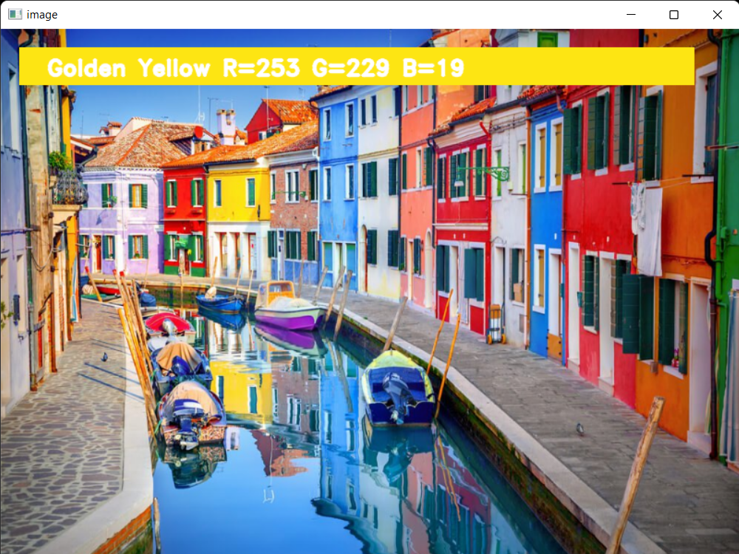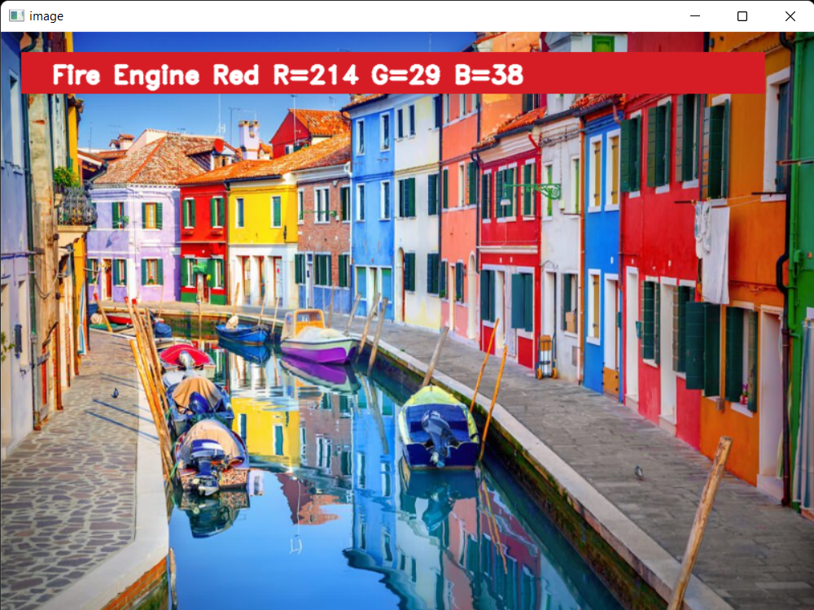

**4**

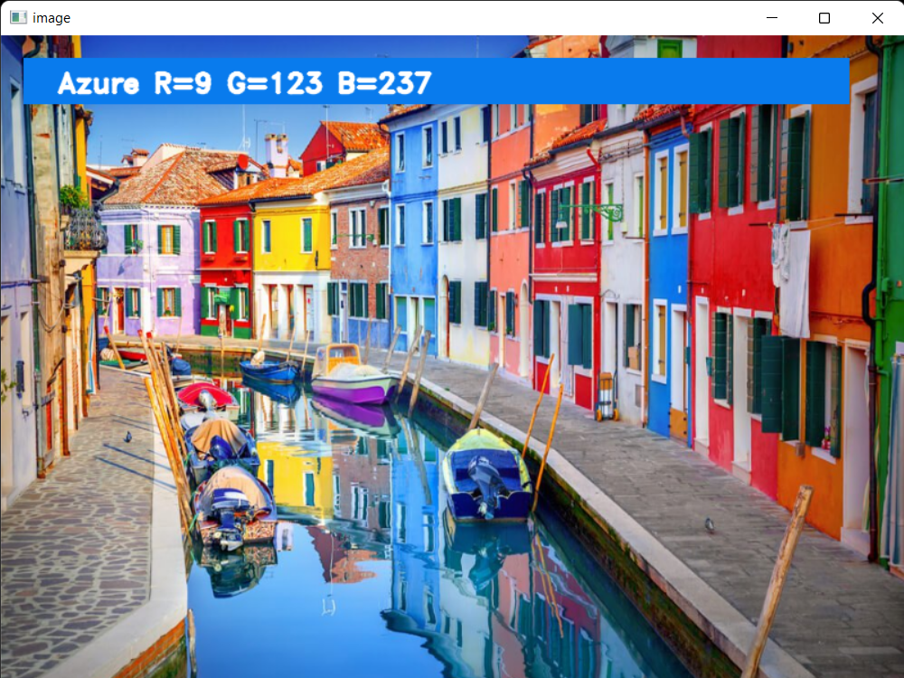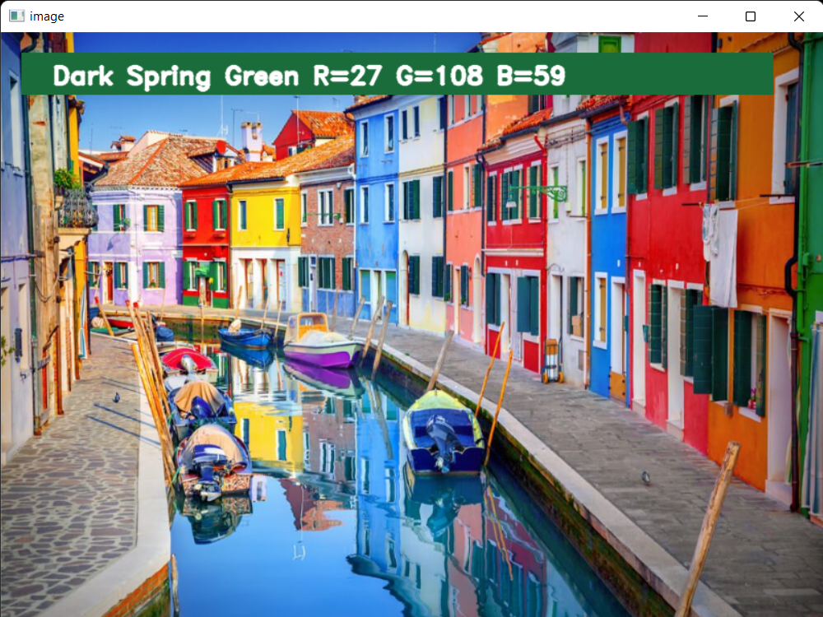

**5**

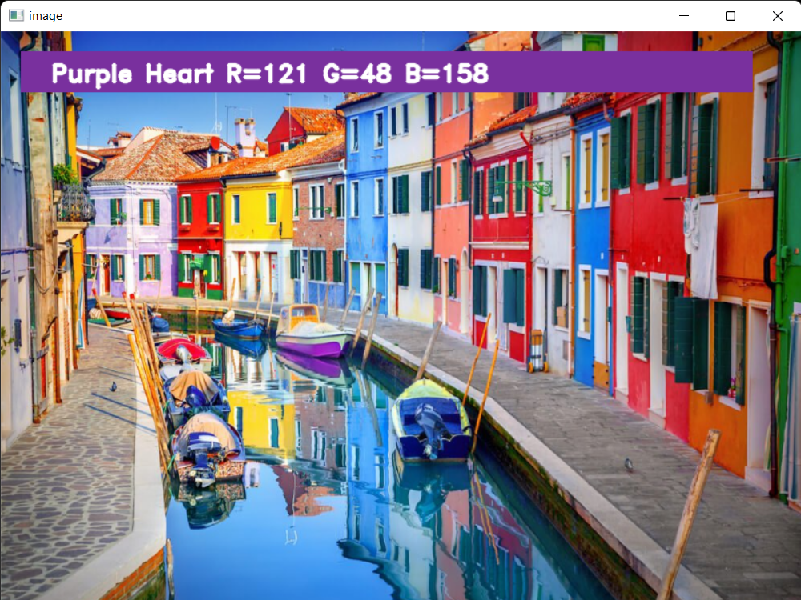

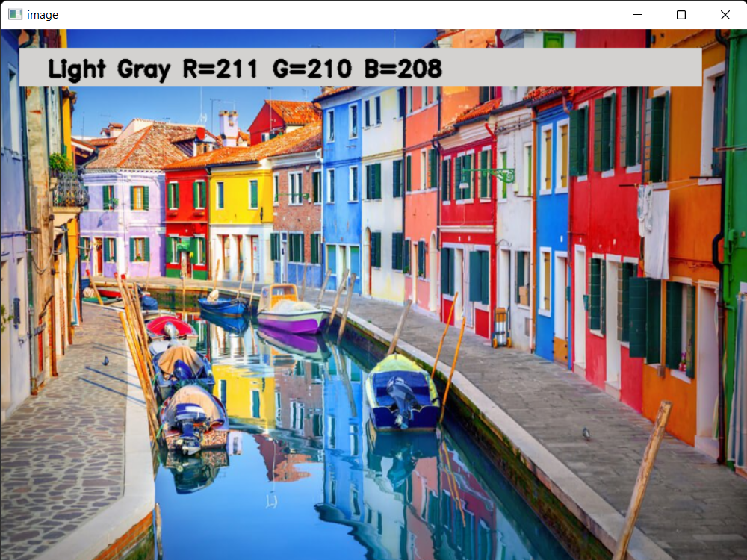

**6**

**Program Code**

Import cv2

import pandas as pd

img_path = 'colorpic.jpg'

csv_path = 'çolors.csv'

#Reading the image with opencv

img = cv2.imread(img_path)

img = cv2.resize(img, (800,600))

#declaring global variables

clicked = False

r = g = b = xpos = ypos = 0

#Reading csv file with pandas and giving names to each column

index=["color","color_name","hex","R","G","B"]

csv = pd.read_csv('colors.csv', names=index, header=None)

#function to calculate minimum distance from all colors and get the most matching color

def getColorName(R,G,B):

minimum = 10000

for i in range(len(csv)):

d = abs(R- int(csv.loc[i,"R"])) + abs(G- int(csv.loc[i,"G"]))+ abs(B- int(csv.loc[i,"B"]))

if(d<=minimum):

minimum = d

cname = csv.loc[i,"color_name"]

return cname

#function to get x,y coordinates of mouse double click

def draw_function(event, x,y,flags,params):

if event == cv2.EVENT_LBUTTONDBLCLK:

global b,g,r,xpos,ypos, clicked

clicked = True

xpos = x

ypos = y

**7**

b,g,r = img[y,x]

b = int(b)

g = int(g)

r = int(r)

#creating window

cv2.namedWindow('image')

cv2.setMouseCallback('image',draw_function)

while(1):

cv2.imshow("image",img)

if (clicked):

#cv2.rectangle(image, startpoint, endpoint, color, thickness)-1 fills entire rectangle

cv2.rectangle(img,(20,20), (750,60), (b,g,r), -1)

#Creating text string to display( Color name and RGB values )

text = getColorName(r,g,b) + ' R='+ str(r) + ' G='+ str(g) + ' B='+ str(b)

#cv2.putText(img,text,start,font(0-7),fontScale,color,thickness,lineType)

cv2.putText(img, text,(50,50),2,0.8,(255,255,255),2,cv2.LINE_AA)

#For very light colours we will display text in black colour

if(r+g+b>=600):

cv2.putText(img, text,(50,50),2,0.8,(0,0,0),2,cv2.LINE_AA)

clicked=False

#Break the loop when user hits 'esc' key

if cv2.waitKey(20) & 0xFF ==27:

break

cv2.destroyAllWindows()

**8**

**Conclusion**

The project “Color Detection with OpenCV” has helped us to understand the concept of using openCV in python. We used panda, numpy and openCV in building this project and with each step, we explored and learnt the various concepts of each of these libraries. We learnt how to use these concepts for solving real-world-based problems through Data Science. Overall, it was an enriching experience for all of us.

**9**